Lesson Plan: Gaining Competence in Video Laryngoscopy

Content
Current Survival Flight Policy and Care Standards call for successful placement of an endotracheal tube with a first-pass (attempt) success rate of at least 90%. While numerous studies have proven the benefits of video laryngoscopy over direct laryngoscopy in achieving first-pass success, Survival Flight has not yet gained proficiency in the skill of video laryngoscopy. I will provide didactic and practical instruction in video laryngoscopy with the intent of making each flight nurse competent in the skill, and continued instruction in order to maintain proficiency in airway management for all of the patient populations and age groups that Survival Flight serves. In order to prepare for instruction and form a foundation for study, each flight nurse should be able to answer the following essential questions:
- How does video laryngoscopy differ from direct laryngoscopy?
- What do you see as advantages that video laryngoscopy has over direct laryngoscopy with the goal of achieving first-pass success?
- What do you see as the limitations of video laryngoscopy as a skill?
- Within the framework of Survival Flight Airway Management Standards and Clinical Guidelines, how might you incorporate the skill of video laryngoscopy into your treatment plan with the goal of achieving first-pass success?

Pedagogy
Student learning will consist of a layered approach including a formal introduction and inservice to the equipment, a self-paced interactive presentation, facilitated practice and final assessment / evaluation. This approach will be utilized as mastery of this complex skill requires not only knowledge of when and why to use it, but how. The group of learners that I will be providing instruction to learn best through the use of multiple senses and learning formats. Practical application will be the measuring stick for success and the students will need to be very comfortable with handling the equipment and realizing which situations this skill will help to ensure success and which situations another method of airway management may be warranted. Learners will therefore gain exposure and then focused, hands on training with subject matter experts (anesthesiologists). Assessment and validation of skill will occur in the form of several testing scenarios that will give context to the psychomotor skills and verify higher levels of understanding with respect to the aforementioned when’s, why’s and how’s. Situated Cognition (Brown, Collins and DuGuid) will be the primary theoretical basis for instruction. The tenets of a Cognitive Apprenticeship stem from this theory.

Content and Pedagogy
The primary goal of this instruction is skill acquisition. In healthcare, it is essential to not just learn a particular skill, but to learn the appropriate context or situation in which to perform the skill. The best method by which to learn complex, invasive skills is instruction from those with proven proficiency and mastery. Experts in the field of healthcare have the proven experience and set the care standards by which the rest of the field practices. The foundation is provided through lecture and facilitated discussion. Skill acquisition is attained through practice. Mastery is attained through complex problem solving while competently performing a specific skill. A Cognitive Apprenticeship is the ideal setting to provide this type of instruction and help ensure achievement of clinical goals. Physical and technical constraints are limited to the functioning of the utilized equipment and the availability of subject matter experts.

Technology
The didactic portion of instruction will be administered online through a Content Management System (CMS). An interactive presentation will be made available to Survival Flight staff following the initial in-service. This presentation will contain pertinent information, engaging activities, a pre- and post test to assess understanding, and is designed to foster the participant’s decision making with respect to the skill, and use of video laryngoscopy. While not absolutely necessary in order to achieve the goal of skill acquisition and proficiency, this presentation will allow staff flexibility in when they learn while providing standardized content to ensure that everyone gets the same information.

The GlideScope Ranger™ is the video laryngoscope that the flight nurses will be learning with. It is currently considered the “gold standard” for video laryngoscopes and is what is currently used in the operating rooms, emergency department and intensive care units at UMHS. An incredibly valuable feature that the GlideScope has is the ability to video record the procedure, adding to the ability to identify and analyze mistakes and provide additional instruction.

The Laerdal SimMan™ will be the high-fidelity manikin used in order to provide scenarios designed to challenge the flight nurse’s ability to perform this complex skill and assess problem solving and decision making in invasive airway management. Human patient simulation is a very important piece of technology in order to train healthcare providers in high stress, high stakes situations without risking the health or safety of actual patients.

Technology and Pedagogy
The primary pieces of technology that will be used best fitting previously mentioned pedagogical strategies are the GlideScope and SimMan. The GlideScope is the training tool that will be utilized in order to learn the complex skill of video laryngoscopy. Experts in video laryngoscopy will provide experience and instruction to the flight nurses utilizing the tool that will be used in actual patient airway emergencies. The video recording feature for the GlideScope will assist the expert in providing more focused instruction to the apprentice. SimMan will provide context to static and isolated instruction by creating the typical environment or patient care situation in which the flight nurse will be asked to perform this complex skill at a proficiency of at least 90%.

Technology and Content
By performing this skill in a controlled environment, utilizing the actual equipment used in an emergency, students will discover essential questions on their own. Through instruction, video debrief and use of the instrument, they will understand differences between video and direct laryngoscopy, arguably two very different skills. Through scenario work utilizing human patient simulation, they will be able to state what the advantages and limitations from their own perspective and experience. Additionally, students will formulate their management plans within the context of current Survival Flight care standards and these standards will guide appropriate decision making with respect to airway management. Use of technology guided by specific instructional goals will allow students to discover the “ big ideas” individually and within the context of their own learning process and clinical skill set.

Assessment
Progression from didactic study to practical training will occur after the flight nurse has successfully passed the post-test within the interactive presentation with a score of at least 80%. The assessment tool (attached to this lesson plan) is designed to ensure baseline competency. The Survival Flight Medical Director will establish proficiency and final credentialing. He will review video taped scenarios and debrief with the individual flight nurse in order to supplement instruction and grant credentialing on an individual basis. It is only after this rigorous assessment process that the flight nurse will be allowed to perform the skill of video laryngoscopy on an actual patient, in an actual emergency.

UMHS Survival Flight GlideScope Ranger® Competency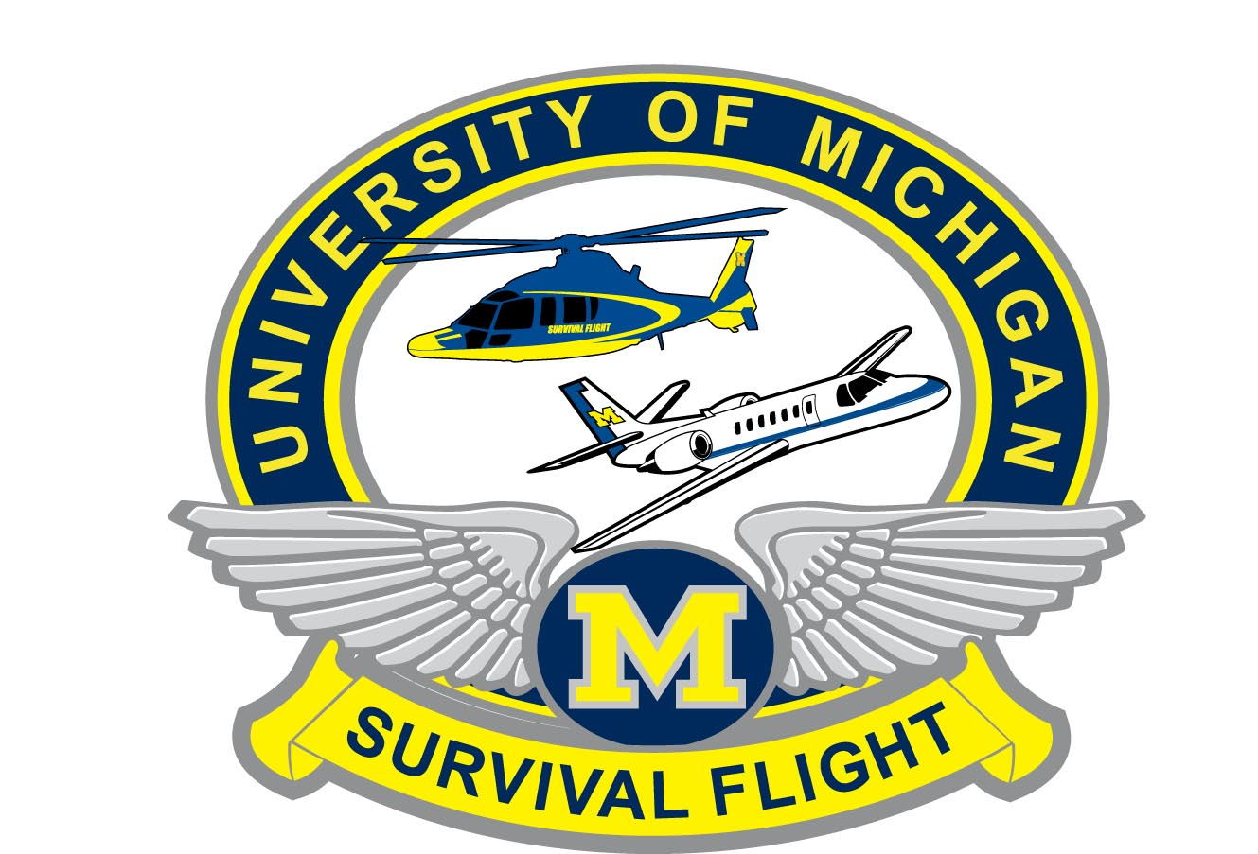

NAME: ______________________________

Step | Required Action | “Complete” (C) or  “Additional Practice Needed” (A)
Identification of Components | - Video Monitor  - Reusable Video Baton  - Size 1-2 (up to 10 kg)  - Size 3-4 (adult size)  - Appropriately sized single-use GVL Stats  - Size 1 (1.5 - 3.8 kg)  - Size2 (1.8 - 10 kg)  - Size 3 (Adolescent to Normal Sized Adult)  - Size 4 (Large Adult)  - Glide – Rite Rigid Stylet
Preparation for Use | - Charging the battery (4 hours for full charge)  - Unscrew DC Socket Protective Cap  - Connect monitor to an AC power source  - Power switch in the on position  - Charge Status Lights  - Orange indicates charging  - Green indicates battery fully charged  - Flashing green indicates 5 minutes before screen shuts off  - Light not lit indicates battery fully depleted  - Understands that a fully charged battery lasts approximately 90 minutes  - Insert the Ranger Video Baton cable in to the port located on the face of the monitor so that the arrows on the cable and monitor line up (same process for changing batons)  - Insert the baton in to the appropriately sized GVL Stat  - Inspect the Stat for rough areas, sharp edges or cracks  - Ensure that the logo on the side of the baton and the logo on the side of the stat are aligned  - Slide the baton in to the stat until it clicks in to place  - Observe the monitor screen to verify that an image is being received
The GlideScope 4-Step Technique | Perform a mouth opening (scissor) maneuver prior to introducing the blade. THEN LOOK:  - In the mouth  - Look in mouth and introduce laryngoscope midline in to the patient’s oropharynx  - At the Screen  - Look at the monitor to identify the epiglottis, then manipulate the scope to obtain the best glottic view.  - In the Mouth  - Looking directly in to the patient’s mouth, carefully guide the distal end of the tube in to position near the tip of the laryngoscope  - At the Screen  - Look to the monitor to complete the intubation; gently rotate or angle the tube to redirect as needed
Working with the Endotracheal tube | - If using an ETT smaller than a 6.0, a Glide Right Rigid Stylet is not available.  - Identification of the correct malleable stylet (sm or med), the correct shaping (probably ~ 60 - 90 deg to match the Stat), and forming a 90 degree thumb “lever” at the proximal end to facilitate the one handed tube advance / stylet withdrawal maneuver  - Insert the ETT behind or immediately adjacent to the GVL Stat utilizing the GVL Rigid Stylet®  - Carefully introduce the distal end of the ETT between the vocal cords  - When introducing the GlideScope and/or the ETT, look directly in to the mouth to avoid damaging the ETT cuff, the patient’s teeth, or the soft tissues such as the soft palate or tonsils  - Advance the ETT while simultaneously withdrawing the stylet with the thumb. The stylet should be withdrawn approximately 5 cm
Removing the Video Baton from the Stat | - Done after each patient use  - Hold the Stat in one hand  - With the other hand, grasp the handle of the video baton and pull firmly  - To reduce the force required to remove the baton from the Stat, use thumb and finger to gently press the Stat collar.
Cleaning and Disinfection | - Use appropriate PPE  - Remove the video baton from the Stat. Discard the Stat  - Wipe off any obvious external debris or contaminants from the monitor and video baton  - Place the cleaning cap to the baton over the connector  - Clean the exterior of the monitor with 70% isopropyl alcohol or mild soap and water (Refer to User’s manual for HIGH-LEVEL cleaning)  - Clean the video baton as needed with 70% Isopropyl Alcohol (Refer to User’s manual for HIGH-LEVEL cleaning)  - Clean Rigid Stylet with 70% Isopropyl Alcohol or 100 ppm bleach solution
Troubleshooting | - No image on the screen  - Powered “ON?”  - Check Battery Life  - Baton properly plugged in to monitor?  - Problems obtaining appropriate view  - Oropharynx clear of blood and debris  - GVL inserted midline and the operator is able to appropriately identify airway structures  - Partner assisting with identification of appropriate airway structures  - Withdraw the GVL approximately 1 cm to reduce the viewing angle (this may allow the glottis to drop in to view)  - Problems inserting ETT in through the glottic opening  - Ensure that the ETT in the rigid stylet is appropriately oriented utilizing the “4 – Step” technique  - Adjust angle of tube pointed towards the glottic opening  - Withdraw stylet once the ETT begins to enter the glottic opening  - Advance the tube while withdrawing the stylet  - Withdrawing the laryngoscope ~ 1 cm may reduce the viewing and insertion angle and allow the ETT to pass more easily into the trachea.

Competency Verified by: _________________________
(PRINT NAME)

_________________________
(SIGNATURE)

References:

- Walls RM and Murphy MF. Manual of Emergency Airway Management (3rd Ed.), Chapter 14. pp 168-172.
- Verathon Inc. GlideScope Video Laryngoscope Tips for GlideScope Video Laryngoscope Insertion: The GlideScope 4-Step Technique. 2011.
- Verathon Inc. GlideScope Ranger and Ranger Single-Use Users Manual and Quick Reference Guide. 2011: Bothell, WA.

